Please, prepare your contribution using this template and the predefine styles. Remove all red text before submitting. Please, do not insert page numbers. You may adapt wording of headings as needed but you need to maintain the format style of the template (fonts of headings and body, margins, referencing style).
Final length of research paper: 6-8 pages (excluding references).

(4 spaces)

TITLE OF THE RESEARCH PAPER (Style: Title – Arial 14pt, bold, Capital letters)
Since we are using double-blind reviewing process, do not add your name, position, affiliation, etc. until to the final camera-ready paper. However, leave room for them. Please ensure that, before submitting, the Author and Last Modified By fields found in the File menu, under the Info tab, are empty.

(2 spaces)
Initials Last name ^{a,}, Initials Last name ^{b}, Initials Last name ^{c},
Initials Last name ^{d}, Initials Last name ^{e}
(1 space)
ª Affiliation, Town, Country, ORCID
^{b} Affiliation, Town, Country, ORCID
^{c} Affiliation, Town, Country, ORCID
^{d} Affiliation, Town, Country, ORCID
^{e} Affiliation, Town, Country, ORCID
(2 spaces)
Conference Key Areas: Please select two Conference Key Areas
Keywords: Please select one to five keywords
ABSTRACT (Style: Abstract heading – Arial 12pt, bold, Capital letters)
Maximum 250 words. Lorem ipsum dolor sit amet, consectetur adipiscing elit, sed do eiusmod tempor incididunt ut labore et dolore magna aliqua. Ut enim ad minim veniam, quis nostrud exercitation ullamco laboris nisi ut aliquip ex ea commodo consequat. Duis aute irure dolor in reprehenderit in voluptate velit esse cillum dolore eu fugiat nulla pariatur. Excepteur sint occaecat cupidatat non proident, sunt in culpa qui officia deserunt mollit anim id est laborum. (Style: Normal – Arial 12 pt)

INTRODUCTION (Style: Heading 1 – Arial 12 pt, bold, Capital letters)
Lorem ipsum dolor sit amet, consectetur adipiscing elit, sed do eiusmod tempor incididunt ut labore et dolore magna aliqua. Ut enim ad minim veniam, quis nostrud exercitation ullamco laboris nisi ut aliquip ex ea commodo consequat. Duis aute irure dolor in reprehenderit in voluptate velit esse cillum dolore eu fugiat nulla pariatur. Excepteur sint occaecat cupidatat non proident, sunt in culpa qui officia deserunt mollit anim id est laborum. (Style: Normal – Arial 12 pt)

METHODOLOGY

Section 1 (Style: Heading 2 – Arial 12 pt, bold)
Lorem ipsum dolor sit amet, consectetur adipiscing elit, sed do eiusmod tempor incididunt ut labore et dolore magna aliqua. Ut enim ad minim veniam, quis nostrud exercitation ullamco laboris nisi ut aliquip ex ea commodo consequat. Duis aute irure dolor in reprehenderit in voluptate velit esse cillum dolore eu fugiat nulla pariatur. Excepteur sint occaecat cupidatat non proident, sunt in culpa qui officia deserunt mollit anim id est laborum.

Section 2
Lorem ipsum dolor sit amet, consectetur adipiscing elit, sed do eiusmod tempor incididunt ut labore et dolore magna aliqua. Ut enim ad minim veniam, quis nostrud exercitation ullamco laboris nisi ut aliquip ex ea commodo consequat. Duis aute irure dolor in reprehenderit in voluptate velit esse cillum dolore eu fugiat nulla pariatur. Excepteur sint occaecat cupidatat non proident, sunt in culpa qui officia deserunt mollit anim id est laborum.
For equations, use the equation editor of Word with the standard settings (Cambria Math 12pt, italic). Equations shall be numbered. An example is given in Eq. (1).
$G=\frac{cf_{1}-0.5f_{i}}{N}∙100$ (1)

RESULTS

Tables
Lorem ipsum dolor sit amet, consectetur adipiscing elit, sed do eiusmod tempor incididunt ut labore et dolore magna aliqua. Ut enim ad minim veniam, quis nostrud exercitation ullamco laboris nisi ut aliquip ex ea commodo consequat. Duis aute irure dolor in reprehenderit in voluptate velit esse cillum dolore eu fugiat nulla pariatur. Excepteur sint occaecat cupidatat non proident, sunt in culpa qui officia deserunt mollit anim id est laborum.
Table 1. Margins of the page size A4 [mm]
Top | Bottom | Inside | Outside
20 | 20 | 25 | 25

Figures
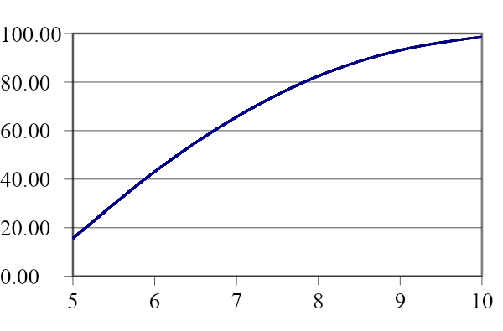 | 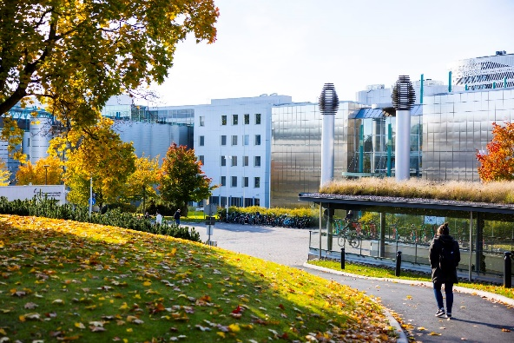
Fig. 1. Drawing (please add Alt Text in the Picture Format tab) | Fig. 2. Tampere University, City Centre Campus (please add Alt Text in the Picture Format tab)

DISCUSSION AND CONCLUSIONS
Lorem ipsum dolor sit amet, consectetur adipiscing elit, sed do eiusmod tempor incididunt ut labore et dolore magna aliqua. Ut enim ad minim veniam, quis nostrud exercitation ullamco laboris nisi ut aliquip ex ea commodo consequat. Duis aute irure dolor in reprehenderit in voluptate velit esse cillum dolore eu fugiat nulla pariatur. Excepteur sint occaecat cupidatat non proident, sunt in culpa qui officia deserunt mollit anim id est laborum.

ACKNOWLEDGEMENTS
Acknowledgments are optional.

REFERENCES (Style: Abstract heading – Arial 12pt, bold, Capital letters)
(Style: Normal – Arial 12pt) The reference style used should follow APA Style. For citation in the text of your submitted paper please use short citations in round brackets. Use only the surname of the author followed by a comma and the year of publication: e.g. (Author, 2025), (Author1 & Author2, 2025) or if citing more than 3 authors use (Author et al., 2025).
Further information can be found at https://apastyle.apa.org/

Please order your references alphabetically.
Since we are using double-blind reviewing process, also references revealing the identity of the author(s) should be made anonymous until the final camera-ready paper.

Reference examples:
Book/Ebook:
Author, A., & Author, B. (Year). Title: Subtitle (edition). Name of Publisher. https://doi.org/10.XXX/XXXXXXX
Journal article:
Author, A., Author, B., & Author, C. (Year). Title of Article. Title of Journal, volume number(issue number), inclusive page numbers. https://doi.org/10.XXX/XXXXXXX
Conference paper in SEFI conference proceedings:
Author, A., Author, B., Author, C., & Author, D. (Year) Title of paper. In Proceedings of the 53rd Annual Conference of the European Society for Engineering Education (pp. inclusive page numbers). https://doi.org/10.XXX/XXXXXXX
More examples:
https://apastyle.apa.org/style-grammar-guidelines/references/examples

Corresponding Author (Arial 10 pt, italic, single space) Initials Last name e-mail address Since we are using double-blind reviewing process, do not add your name, position, affiliation, etc. until to the final camera-ready paper.

